**Array** is a collection of similar type of data. It is fixed in size means that you can't increase the size of array at run time. It is a collection of homogeneous data elements. It stores the value on the basis of the index value.

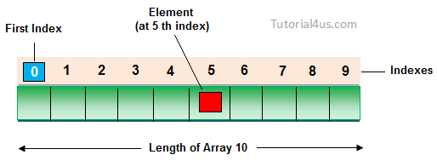

## Advantage of Array

**One variable can store multiple value:** The main advantage of the array is we can represent multiple value under the same name.

**Code Optimization:** No, need to declare a lot of variable of same type data, We can retrieve and sort data easily.

**Random access:** We can retrieve any data from array with the help of the index value.

## Disadvantage of Array

The main limitation of the array is **Size Limit** when once we declare array there is no chance to increase and decrease the size of an array according to our requirement, Hence memory point of view array concept is not recommended to use. To overcome this limitation in Java introduce the collection concept.

## Array Declaration

Single dimension array declaration.

## Syntax

1. int[] a;

2. int a[];

3. int []a;

## Array creation

Every array in a Java is an object, Hence we can create array by using **new** keyword.

## Syntax

int[] arr = new int[10]; // The size of array is 10.

or

int[] arr = {10,20,30,40,50};

## Accessing array elements

Access the elements of array by using index value of an elements.

## Syntax

arrayname[n-1];

## Access Array Elements

int[] arr={10,20,30,40};

System.out.println("Element at 4th place"+arr[2]);

## Types of Array

There are two types of array in Java.

* Single Dimensional Array
* Multidimensional Array

**Example**

**class** Test_while {

**public** **static** **void** main(String[] args) {

**int**[] onedimensionalarray= **new** **int**[5]; // Array declared with size

onedimensionalarray[0]=10; // Value initialized

onedimensionalarray[1]=20;

onedimensionalarray[2]=30;

onedimensionalarray[3]=40;

onedimensionalarray[4]=50;

// Values are printed in output

**for**(**int** i=0; i<5;i++){

System.***out***.println("the value in onedimensioanlarray are " +onedimensionalarray[i]);

}

}

}

**Output**

the value in onedimensioanlarray are 10

the value in onedimensioanlarray are 20

the value in onedimensioanlarray are 30

the value in onedimensioanlarray are 40

the value in onedimensioanlarray are 50